Woods Procise
Dr. Wanless
Advanced Sports Analytics
26 October 2025

Phase II of the Final Project:
NFL Big Data Bowl 2026 Preliminary Exploration

Idea#1: Team Defensive Coverage Outcome Analysis

Motivation: “Why this matters”

The first football analytics question I am aiming to explore focuses on team pre-snap alignment and motion, with player movement being the constant theme for the 2026 NFL Big Data Bowl. The NFL has evolved tremendously over the course of its existence and teams around the league are adjusting their schematics and strategies more rapidly than ever before. With such a large talent pool in the NFL today, coaches are searching for any advantage they can get. I am exploring pre-snap coverages to see how NFL coaches leverage disguise and trickery in their play calling and am seeking to evaluate the effectiveness of their deception. A pre-snap analysis aims to evaluate play outcomes including play types, route combinations, and defensive coverages. For this project, I am going to specifically investigate the defensive side of the ball and focus on what NFL defenses have the most success with pre-snap motion and deceptions.
The data sources that I will be using the answer this question are from the 2023 NFL season including play-by-play, players, games, weekly tracking data. This data will be pulled from the following NFL CSV files: games.csv, players.csv, plays.csv, player_play.csv, and tracking_data_2023_wk.csv from week 1 through week 19. The player and games data will be useful in identifying unique instances for the specific player being analyzed and the game situation. This foundational data allows for the overarching question to be answered through analyzing players pre-snap movements and formations by retrieving data from the play-by-play, plays, and tracking files.
Analyzing defensive pre-snap motion deception and formations should provide immense value to coaches and players. For coaches, the insights gained through predicting play outcomes based on how the players are lined up will inform them what defensive coverages and deception movements have been most and least successful. With this, coaches can adapt to increase the usage of what has been working for them and adjust certain coverages that have been less effective. From a player standpoint, each defensive player has their own strengths and weaknesses, and this data will show players what areas of their game they can improve on. Certain player personnel packages may be far more successful in pre-snap deception movements than others. The same logic applies to defensive coverages as certain players may be more comfortable in certain defensive schemes than other players. Through analyzing play-by-play data on defensive player pre-snap movements and coverages, we can find insights on team performance, while also narrowing the focus into gathering data for individual player performance in the context of various coverages and defensive play types.

Methods

The data collection for this project was an extensive process that involved gaining access to the 2026 NFL competition data files, cleaning, filtering, and merging the data, to ultimately formulating predictions and analyses to answer the research question. Due to inconsistencies in object types and format among the data files, there was a significant need for data cleaning and filtering. Merging the data was not mandatory, but highly beneficial by creating an easier access route to the retrieve specific data from the CSV files.

Data Accessed: games.csv, supplementary_data.csv, players.csv, player_play.csv, plays.csv, tracking_week.csv

Data Cleaning, Filtering, and Merging:

STEP 1: After successfully importing the necessary NFL data files that I will pull data from to gain insights about my research question, I needed to find the path to access the tracking data. I wanted to ensure I have direct access to data from each week throughout the 2023 NFL season, and the csv files from each week successfully loaded in this data.

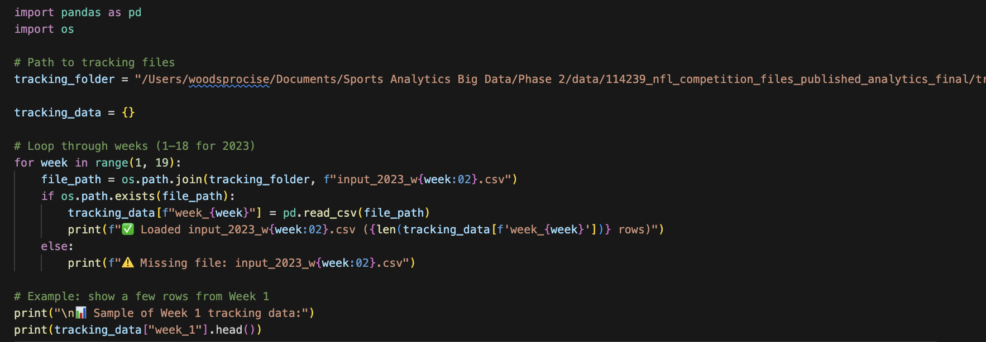

STEP 2: I decided to first focus specifically on merging the tracking data because I know that the format of all the tracking CSV files from weeks one to eighteen are consistently formatted. Because this is true, I wanted to merge the tracking data into one data frame to make it all more easily accessible. The data cleaning process would otherwise get messing if I tried merging the tracking files with the games, players, and play-by-play data before ensuring the formatting is consistent across all files.

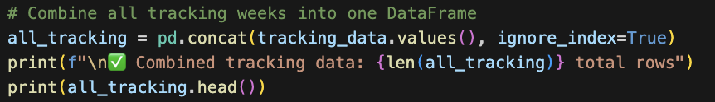
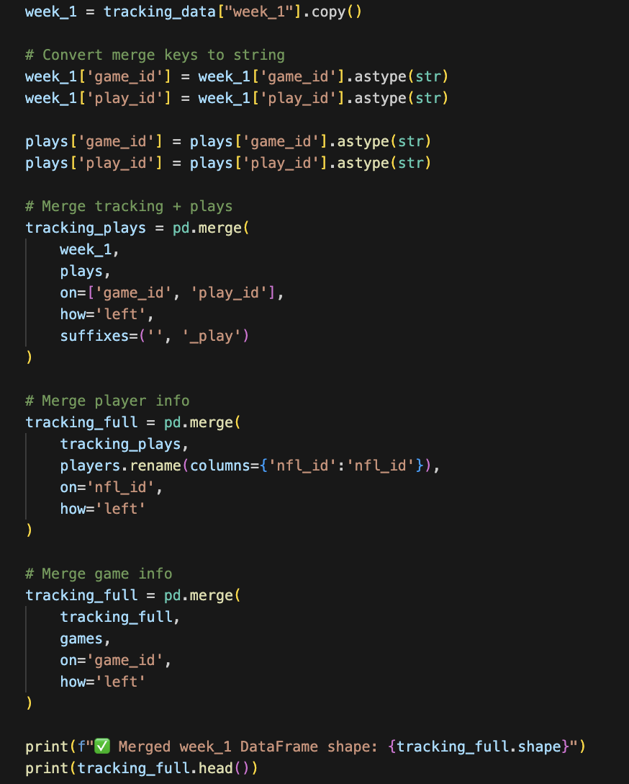
STEP 3: Once I merged all the tracking data files into one data frame, I loaded the supporting CSV files including games.csv, players.csv, player_play.csv, plays.csv, and supplementary_data.csv all under one NFL competition data files folder. Before merging the tracking files with the supporting files, I cleaned up the data files as there were major inconsistencies in data types across the CSV files. In the code below, I reformat the keys within the data frame to strings to ensure the IDs match up with each other. Cleaning the data was necessary as the data types varied between floats, integers, and objects when I ran a check on the data. These inconsistencies prevented a merge between the files, but once the keys were all reformatted to objects, the merge between the tracking and supporting data was successful. The data cleaning involved standardizing column names in addition to creating a consistent format among the data types.

STEP 4: After unsuccessful attempts in merging all the data including the games, players, play-by-play, and player play data with the tracking and supplementary data, I decided to reverse course and simplify my process. Steps two and three, with dark blue color, are the steps I am going to back track and significantly adjust, although I deem it important to document them as they represent a part of the process that I went through, despite my decision to change course. I realized that merging all these data files was an extremely complex computing action for my laptops system, as together, these data files create hundreds of thousands, if not millions of rows and columns. This complexity not only could cause my computer to crash and take an extremely long time to merge but would be exceptionally difficult to clean and find results with the null values, overlap, and data type inconsistencies. I began to resolve this process by first deleting the unnecessary data that I imported by deleting all csv files aside from the tracking and supplementary CSV data files. These CSV files hold sufficient information to complete my analysis while eliminating redundant data. After this, I decided to merge the input and output NFL tracking data for every week of the 2023 NFL season, even though I am only going to be analyzing games from week 1.
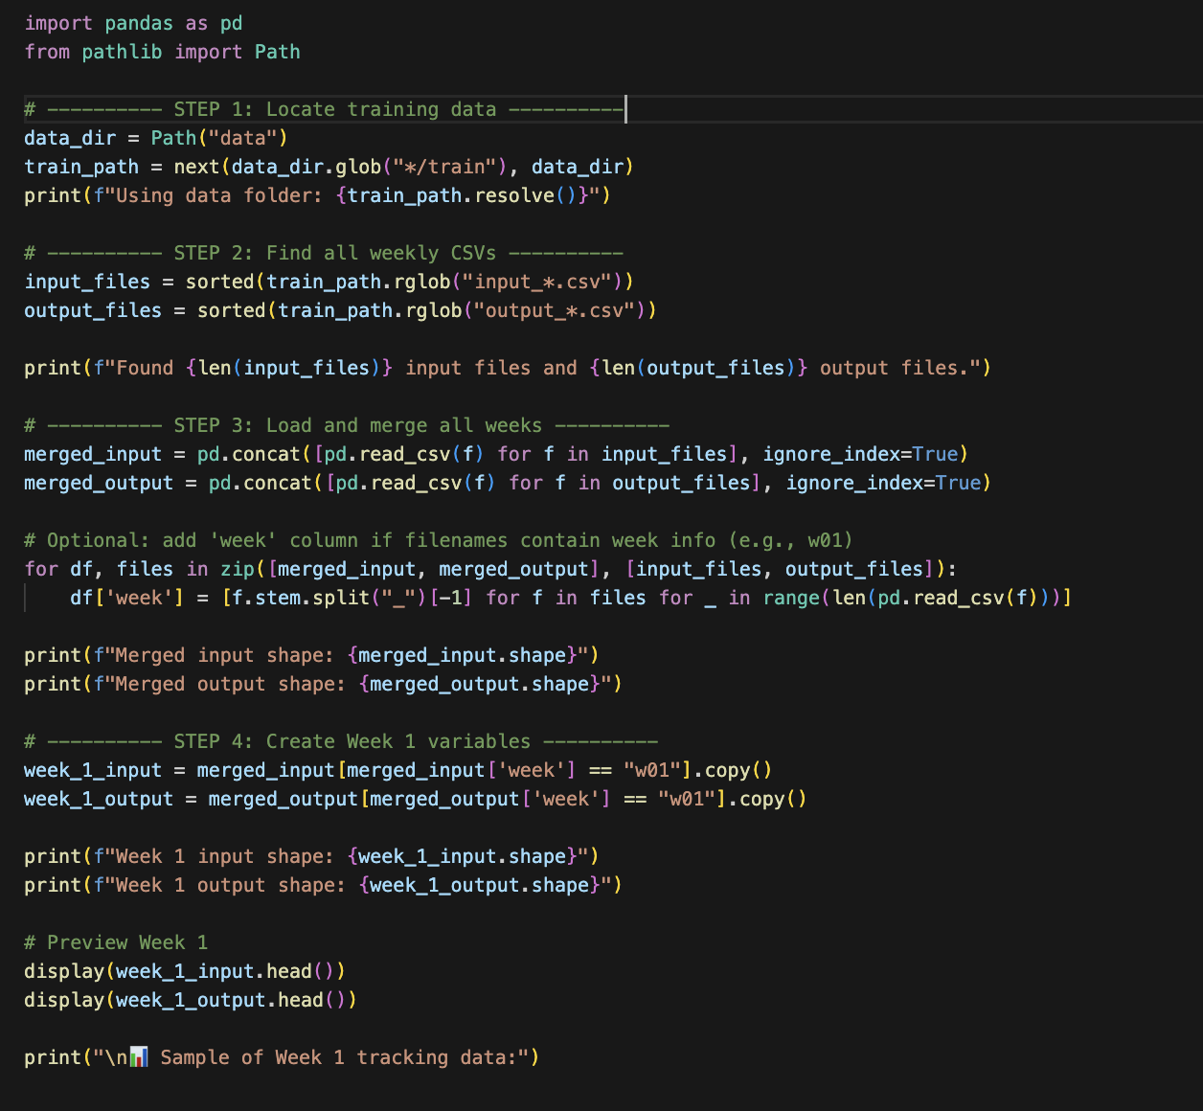

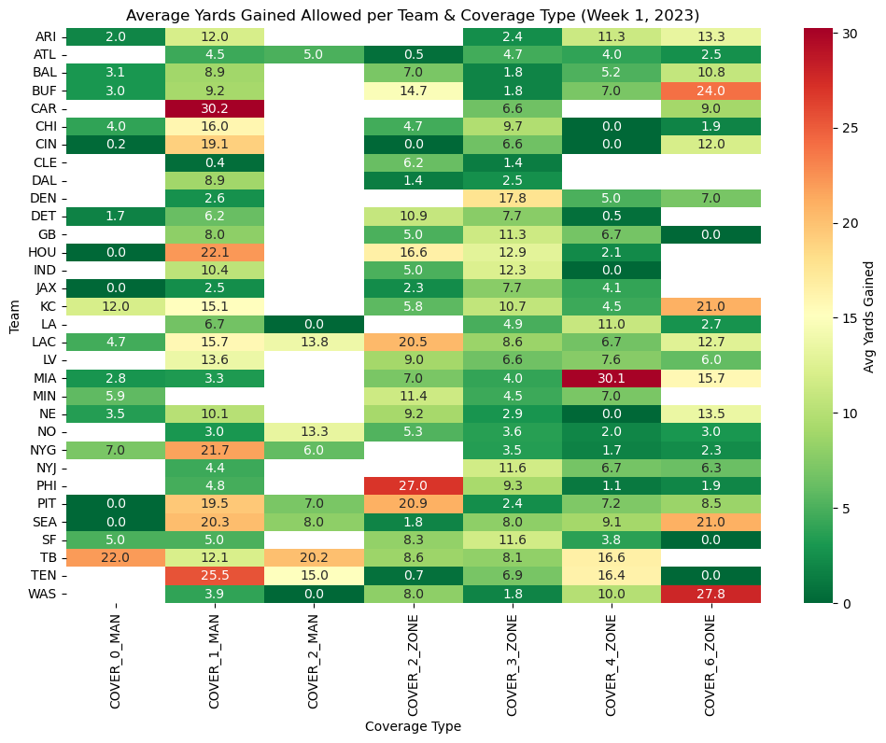
STEP 5: After merging the NFL week by week tracking files, I additionally loaded in the supplementary data CSV file. All in all, the data that I will be accessing included the week 1 input, week 1 output, and supplementary data files. I wanted to first explore how each NFL team performed defensively in week 1 in various defensive coverages by analyzing the average yards allowed per coverage type. I first merged the play identifiers to calculate the average yards given up for each defensive coverage. To evaluate each team’s defensive success, I grouped each NFL team with defensive coverage type found in the supplementary data file. The first exploratory visualization I created is a heatmap of each team’s yards allowed varying on defensive coverage, with red being very poor and dark green representative of success in each coverage for each team.

Results

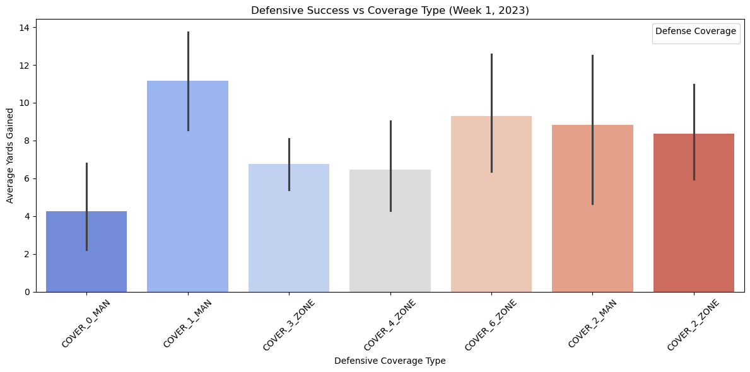

Building off my exploratory visual, I first wanted to create a visual that was much easier to interpret. Rather than overloading viewers with detail heavy information on each team, I chose to simplify my visualization to show results for the most effective defensive coverages league wide in week 1 of the 2023 NFL season. Looking at all the team’s statistics can be overwhelming, while league averages are far clearer. In the above visualization, the x-axis is represented by the type of defensive coverage while the y-axis illustrates the average yards gained. The higher each bar goes, the more yards allowed per coverage type. The defensive coverage that was most successful league wide in week 1 was cover 0 man, as defenses gave up slightly above four yards per play. This likely is in part due to this coverage being called in short yardage situations, where the offensive is only looking to gain the necessary yardage to gain a first down. On the flip side, cover 1 man gave up a league high, averaging over 10 yards allowed per play. While this visualization does not provide any major trends in the data, it contributes to my initial motivation in analyzing the success of various defensive schemes. None of the coverage types stand out among the others, although this visualization points at the importance of having a balanced defensive scheme. No coaches want to be easily predictable in their play calling, and a healthy balance of man to man and zone coverages are imperative in keeping NFL offenses guessing. This visualization shows that all coverages will allow yards, situation play calling is important for a defense to have success.

Additionally, I created a defensive performance quadrant by creating a metric for defensive success rate. This scatter plot has a lot going on but with proper elaboration, it can be explained to coaches or front offices to provide them insights on how their defense stacks up to the rest of the league in a metric called ‘success rate’. A defensive success rate is defined by the average yards they give up based on the expected offensive yards. I did not want to define success rate based on a fixed yardage due to unique circumstances in each game.

Expected yards per down: 1st down = 4, 2nd down = 3, 3rd down = 2, 4th down = 1

This metric measures the rate at which NFL defenses hold offenses to under the expected yards on each play while providing insights to teams who gave up the most yards on average throughout the week 1 games in 2023 as well as their success rates. For instance, The Cincinnati Bengals had the lowest success rate in holding teams below their expected yards per play whereas the Cleveland Browns succeeded in holding opponents below the expected yards gained at an incredible almost 70% rate. The bottom right quartile is where NFL teams want to be as it signifies both a high success rate and a low yardage allowed on average. There are limitations to this visualization, although it effectively highlights teams that are struggling at stopping opposing offenses consistently as well as defenses that flourished in week 1 of the 2023 NFL season.

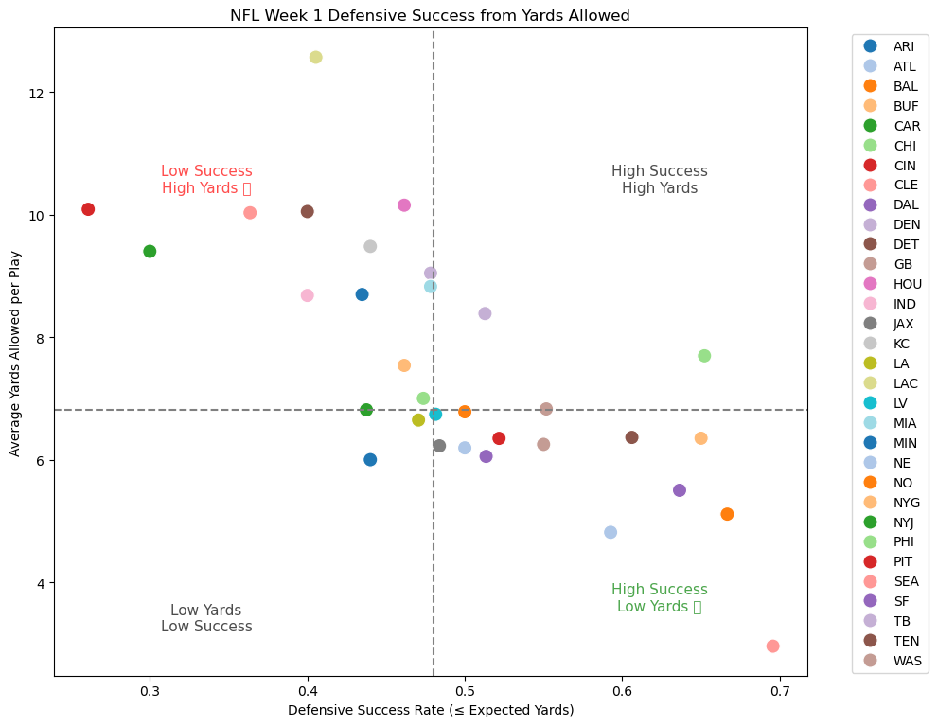

Discussion

There were many limitations in this research idea reaching its full potential and effectiveness in my analysis. First, I was working with too much data which was difficult for my computer to process, but I acknowledge the need to likely incorporate more outside data to maximize the data insights I can provide to coaches, players, and front offices. The goal with this project idea is to dive into pre snap movement as well as analyze the success of each defensive coverage for various teams. In the visuals provided, there are good general insights are league averages as well as team defense success, but I failed in producing a visualization that represented everything that I am seeking to that was clear and easy to read. I experimented with various quadrants to visualize the data, although I have been unable to produce a desired visualization thus far.
One key limitation important to note that how I define expected yards per down is very simple, and may be inaccurate or unfair to defenses, creating limitations in my analysis. I tried to provide a reasonable benchmark in how I defined expected yards per down, and it can be an effective reference in many situations despite limitations. A defensive success rate is the percentage that a defense holds an offense to under their expected yards. I am proud of the progress I made but acknowledge that much more work is necessary to get to where I want to get with this idea. A collaboration that could be beneficial is taking a second look at incorporating play by play data into the equation to ideally produce a cleaner visualization working with this many data. Additionally, I could look specifically at one or two teams and analyze how they fared in week 1 of the 2023 NFL season with different coverages, although I am determined to find a solution to my current goal of displaying insights for all NFL teams’ defensive success in various defensive coverages.

Idea#2: Analyzing Offensive Player Movement

Motivation: “Why this matters”

The next football question that I am aiming to explore revolves around offensive player movement during the play. I chose one example play to dive into in a week 1 matchup during the 2023 NFL season between the Kansas City Chiefs and the Detroit Lions. I wanted to analyze player movement throughout a play to gain insights on player speed, decision making, and game awareness. This tracks back to the coach as well, as analyzing player movement during plays can provide insights on their overall offensive scheme and its effectiveness in getting skill position players open in space to make plays. Data insights revolving around offensive player movement provides coaches with sufficient information to evaluate their players. For every play, with an immense talent level in the NFL making little room for error, it's imperative that players are in the right spots at the right times.
The main data sources that I will be referencing in this analysis are week 1 tracking data, specifically the input data, as well as supplementary data files. In the supplementary data files, I will be extracting data including home and visitor team name abbreviations as well as information on the possession team and the defensive team to ensure I track the correct players on offense and defense. This type of tracking seeks to create visualizations that additionally track the football in the air. Coaches can effectively analyze quarterback movements, such as a quarterback’s ability to escape a pocket that is collapsing and show off a level of elusiveness. Players can also benefit from analyzing their movement during a play. For one, they can focus on taking the best possible angle to get to their spots if they are running a route by improving routes that led to incompletions while also trying to emulate plays in which they caught passes and had success. By looking at their routes and movement throughout a play, players should hopefully gain insights on how to most effectively attack different types of defensive coverages and create leverage in real game situations accordingly. Ultimately, this type of player tracking through visualizations allow coaches and players to gain a 360-degree view on ways that they can improve their offensive play calling, routes, blocking, scrambling, and any kind of movement throughout various plays.

Methods

To answer this question revolving around offensive player movement, I am accessing the input and output tracking data as well as the supplementary data CSV files. I have not utilized the output data yet, but potentially will down the road, but I am utilizing many of the data in the week 1 input tracking data as I am primarily focused on gaining insights on player movement.

Data Accessed: input_2023_w01.csv, output_2023_w01.csv, supplementary_data.csv

Data Cleaning, Filtering, and Merging:

STEP 1: I started with importing necessary libraries and CSV files before filtering the data to look at one specific play. I choose to investigate a specific passing play from the Chiefs vs Lions game. I began by defining the data from play 194 and filtering it into the columns that I need to analyze the whole play. The filtering sorted an array of columns, but I was particularly fascinated by the seemingly endless rows for each play, let alone the entire data set. After filtering the data, I cleaned a few columns by eliminating duplicates as columns such as ‘nfl_id’ and ‘game_id’ existed in more than one of the CSV data files.

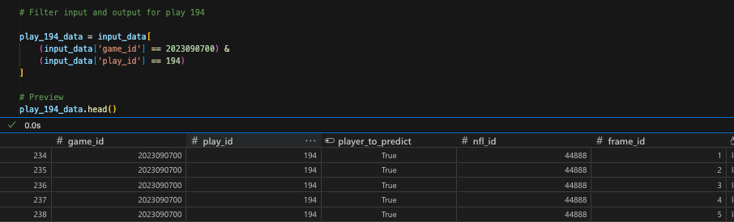

STEP 2: I wanted to get a preliminary gauge on the player movement for play 194, which I did by grouping play_194_data by ‘nfl_id’ to then plot player movement and specify the player using ‘player_name’. This was a much more insightful visualization below than I initially thought it would be. I acknowledge the lack of clarity and confusion with the different colors, but the offensive player route tracking and defensive coverage is exciting to look at. Based on my analysis, the Kansas City Chiefs have the ball with quarterback Patrick Mahomes dropping back to pass the ball. All the receivers look tightly guarded aside from wideout Sky Moore who looks to have created separation down the seam, referencing the light blue dotted line on the top of the graph. The limitation for this graph is I cannot tell where the quarterback threw the ball, although another insight is the defense appears to be playing a cover 1 man zone, with a single high safety, linebacker spy on the quarterback, and the cornerbacks playing man to man coverage.
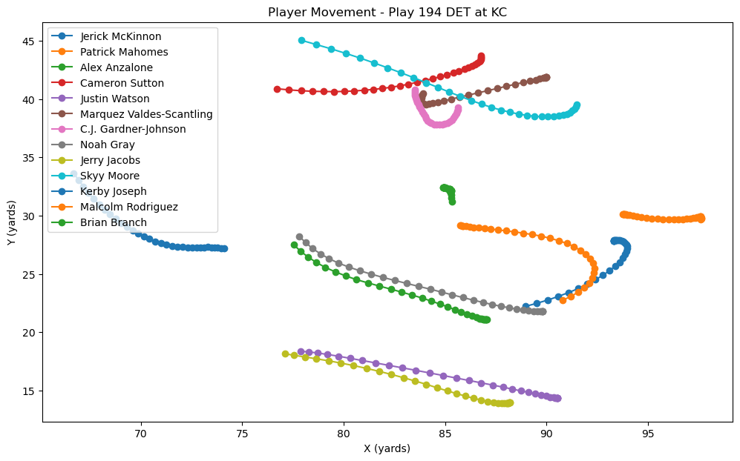

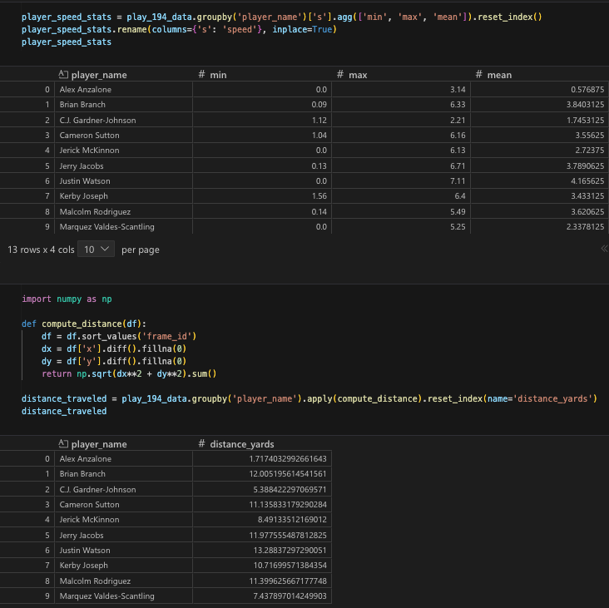
STEP 3: From here, after a bit of data filtering and cleaning, I wanted to access data on players speed and their distance traveled. These kinds of statistics seem beneficial to coaches and players, especially coaches, as they can put their skill position players in the best situation to succeed within the offensive system given each of their individual skillset and abilities. Player speed and distance ran per play are two of many insightful indicators that NFL data tracking can provide through many small frames measuring analytics about players throughout a play.

STEP 4: The lone merge in my data structuring process entailed merging supplementary data into tracking data by ‘play_id’. I did this with a goal to assign the players involved in play 194 to a team, as the input tracking data does not contain a ‘team’ column. My aim was to assign players on the ‘possession_team’ to the offense/home team and players on the ‘defensive_team’ to the defense/visiting team with the primary goal of making my visual findings easier to interpret. I aimed to make color code the offensive players with red dots and the defensive player with blue dots, although have yet to successfully do perform this coding operation, as thus far, all the players are the same color.

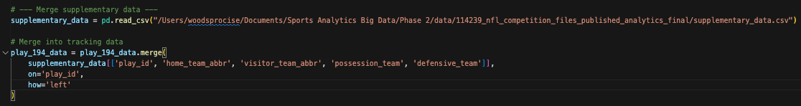

Results

I am aiming for an animated visualization that successfully includes every important detail to represent this play in its fullest form yet have struggled to produce a desired visualization after many adjustments to my code. The visualization below is the furthest I have come after multiple adjustments. I will further discuss limitations in the discussion section, but the good news is that I successfully created a live movement animation which will help with this play analysis once additional variables are resolved. A difficulty as well as similarity perhaps is that both offensive and defensive players are the same color. Without clear distinct team columns imported, I have not yet found the alternate solution to color coding the players. The positive insights this visualization does provide mainly focus on the offensive players routes and whether they successfully create separation from their defenders or not. I was able to output a different color for the football but have not been able to track it in the air yet, unless perhaps the quarterback was sacked on the play.
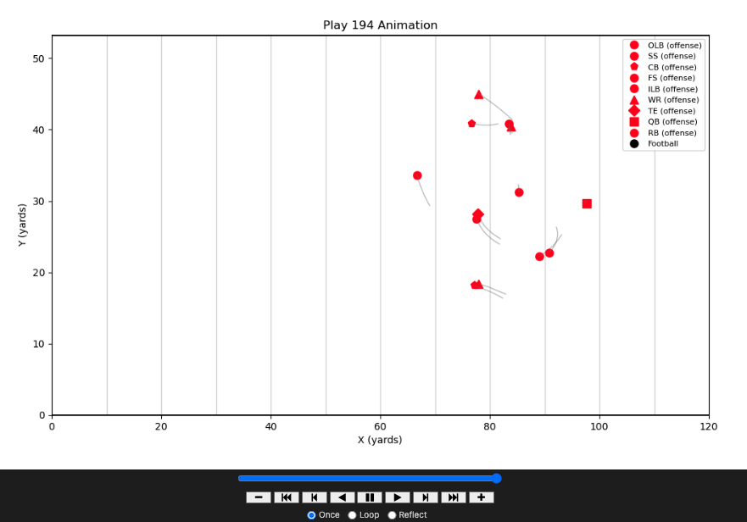

In the animation below, I was able to make slight progress by color coding the QB, RB, and WR in the key, although was still ineffective in translating that to the visualization. While the shapes connecting to the key help distinguish the players slightly, coaches and players don’t want to have to take time to analyze the data, as it need to be easy to read and gain insights. It is imperative that I take this visualization to the next level in providing a complete analysis for an NFL team. Another difficulty has been the processing rate when I adjust the interval, a merge, or if-else statement. Overall, there have been some bright spots from these visualizations, but it is evident that improvements need to be made for them to reach their full effectiveness.
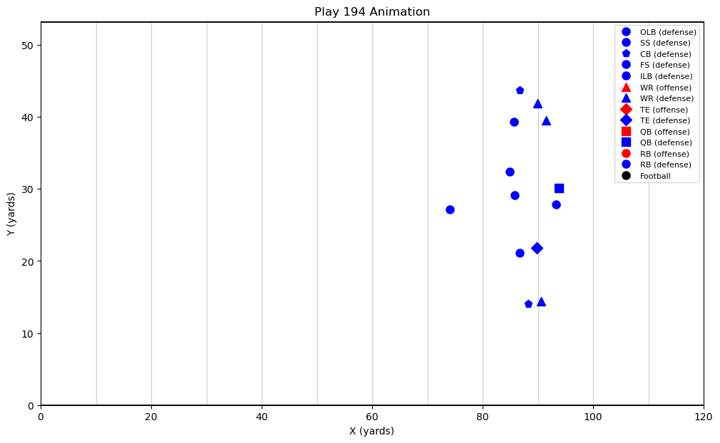

Discussion

There are evident limitations to the visualizations preventing me from fully analyzing offensive player movement to the fullest, but I am aiming to eventually overcome these roadblocks. A main limitation that I plan to resolve is importing a team’s CSV file to making it much easier and direct to assign players to teams. This alone will vastly improve how I am able to visualize my findings. One limitation is that I am working with a dataset that seems infinite when looking at it, as each play alone has hundreds of rows of tracking data. This is a restriction as computers can only process up to a certain amount of data at once. Even for my case, I selected a certain number of defenders to analyze for even just one play, rather than looking at 11 vs 11 due to the vast amount of data. Not to say it isn’t doable to analyze 11 vs 11 player movement, but it speaks to the difficulty of just providing an analysis of one play, then imagining seeking larger amounts of data to compare plays throughout a game or a season.
Looking towards the 2026 NFL Big Data Bowl competition and knowing the emphasis that the competition puts on analyzing and predicting player movements, this is certainly an idea worth pursuing and that I will enjoy pursuing. There is a lot of potential and room to grow, especially acknowledging the shortcomings and areas where I have been unable to produce as effective an output as I would like to. Initially, with my first idea, I made the mistake of importing too much outside data as well as trying to merge all of it, resulting in a mess and virtually starting over. As a result, I prioritized simplicity in my next analysis, although this has felt just as complex, but I am optimistic this idea has potential if I am able to incorporate outside data sources in addition to the tracking and supplementary data that I am currently working with.

